Introduction to Pyspark
What is pyspark:
Python library used to process and analyze huge amount of data across multiple computers.
Python API for Apache Spark
Pyspark will distribute the work across multiple computers to process the huge data effectively.
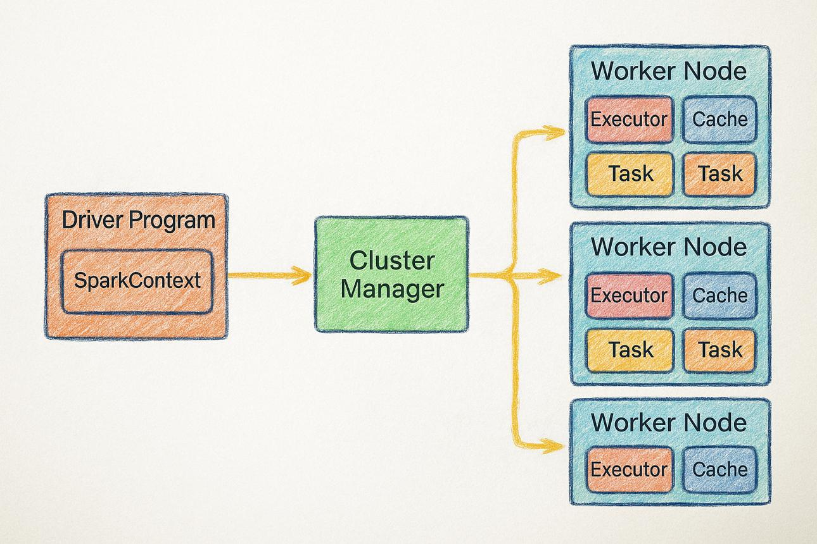

What is a Cluster: Group of computers working together as one system to complete a task.
In PySpark, a cluster is used to process large amounts of data by distributing the work across multiple computers.
- Driver: Plans and coordinates the processing.
- Workers: Computers that perform the assigned work.
- Executors: Processes running on workers that execute tasks and may cache data.
- Cluster: The collection of computing resources working together.
Advantages of Pyspark
- Fast Processing: process large datasets efficiently by parallel processing
- Handle big data: process huge data by distributing work across multiple computers
- Distributed processing: divide large task into smaller and executes across multiple computers
- Support python
- Data processing and cleaning: filtering, handling missing values, remove duplicates, join tables and transform data
- Integration with big data tools: work with Databricks, cloud storage and data warehouses
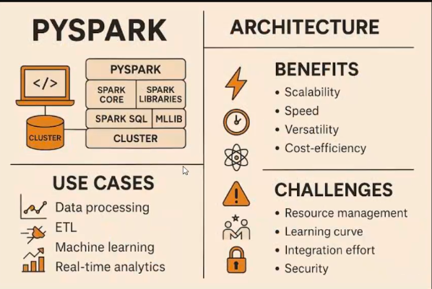
- Fault tolerance: recover computations when worker fails

